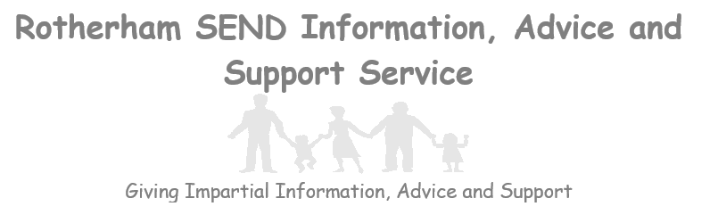
What to do when you receive your draft EHC plan…

Following the completion of an EHC needs assessment, if the local authority (LA) decides to issue an EHC plan, they will send you (the parent/young person) a draft version of the plan. This is an opportunity for you to read through the information contained in the plan and check whether it contains everything it should. Along with the draft EHC plan, the LA must give notice that you have 15 calendar days in which to:
- make comments – ‘representations’ – about the draft EHC plan
- request a meeting with the LA to discuss the draft plan (the LA is legally required to agree to meet you if you ask)
- request that a particular school or other institution is named in the final EHC plan

Below is a checklist to refer to when reading through the draft plan – this explains what to look for. If you are not happy with any aspect of the draft EHC plan, or the reports attached to it, you can suggest amendments you would like made to the EHC co-ordinator. As you read through, make a note of any information you feel is incorrect/outdated, highlight if there are any gaps in information and make a note of any points from reports which you plan to request be added. Share these views with the EHC Co-ordinator within the 15 calendar days of receiving the plan – you may find it useful to use IPSEA’s model letter for responding to a draft EHC plan as a starting point.

What a draft EHC Plan should contain and tips on what to look out for
Section A | All About Me  My Parent/Carer’s Views | This section should include:  - Details about your child or young person’s aspirations and goals for the future. When agreeing the aspirations, consideration should be given to their aspirations for paid employment, independent living, and community participation.  - Details about play, health, schooling, independence, friendships, further education, and future plans including employment (where practical).  - This could include what is important to them in these areas  - Things that are working well at home and school  - Things they enjoy doing  - A summary of how best to communicate with the child or young person and engage them in decision-making. E.g., Do they need information breaking down into small chunks, presented visually or to be given more time to process information/questions?  - A summary of the child or young person’s history  - If written in first person, the plan should make clear whether the child or young person is being quoted directly, or if the views of the parents or professionals are being represented.  - Parental Views e.g. important things to know about your family, things that are working well at school and home, and things that aren’t working well and you would like to change.

In a Rotherham EHC plan sections B, E and F are contained alongside each other to make it easier to identify what the child’s special educational need are, what outcomes they are to be supported to achieve and the educational provision they will require to help them achieve this.

Section B | What are the child or young person’s strengths  related to learning in this area?  What are the child or young person’s special educational needs related to learning in this area? | A SEN is a learning difficulty or disability which requires special educational provision. Special educational provision is educational or training provision that is additional to, or different from, that made generally for others of the same age in ordinary schools or other settings, or any educational provision for a child under two.  - Section B must specify all of the child or young person’s identified special educational needs (SEN) (section 37 of the Children and Families Act 2014).  - SEN is broken down into 4 main areas of need:  - Communication and Interaction  - Cognition and learning  - Social, Emotional and Mental health  - Sensory and/or Physical  - This section may include needs for health and social care that are treated as special educational needs because any provision would educate or train a child or young person.  Tip - Ask yourself…  - Are all of your child’s special educational needs specified in section B?  - Sometimes there are needs that have not been identified in section B, in which case we advise you to read through the supporting reports/evidence to see if this information is mentioned in the reports and if so, you could ask for these points to be pulled through into section B  - Sometimes information regarding a child’s needs/what they find difficult can be found in other sections of an EHC plan by mistake (like section A), in which case you could ask for these to be moved to section B
Section E | Outcome  Preparing for adulthood themes  Steps to achieving outcome  Step  Date to be achieved by | - There should be a range of outcomes over varying timescales, covering education.  - There must be a clear distinction between outcomes and provision. The provision should help the child or young person to achieve an outcome; it is not an outcome in itself.  - The section can include:  - Steps towards meeting the outcomes.  - The arrangements for monitoring progress towards these outcomes, including review and transition arrangements for the EHC plan and the arrangements.  Tip - Please bear in mind…  - Outcomes should be specific, measurable, achievable, realistic, and time-bound  - Outcomes should follow on from the aspirations identified in Section A  - Short-term, service level targets should be included as an appendix, not as outcome  - Schools do not have prescribed duties to meet with parents or review EHC plans outside of annual reviews, so it may be helpful to ask for it to detail in Section E how this will be done – for example, that they will meet with parents three times a year to assess progress towards shorter-term targets.
Section F | Provision  Support needed  To be provided by:  Staff/ student ratio  How much/ quantity  How often | - For children aged two or more, special educational provision is educational or training provision that is additional to or different from that made generally for other children or young people of the same age by mainstream schools, maintained nursery schools, mainstream post-16 institutions or by relevant early years providers. For a child under two years of age, special educational provision means educational provision of any kind.  - Provision must be detailed and specific and should normally be quantified, for example, in terms of the type, hours and frequency of support and level of expertise, including where this support is secured through a Personal Budget.  - Provision must be specified for each and every need specified in section B.  - It should be clear how the provision will support achievement of the outcomes.  - Where health or social care provision educates or trains a child or young person, it must appear in this section.  - The plan should specify:  - any appropriate facilities and equipment, staffing arrangements and curriculum.  - any appropriate modifications/exclusions to the application of the National Curriculum, where relevant. This should be in detail and explain the provision which it is proposed to substitute for any such exclusions in order to maintain a balanced and broadly based curriculum.  Tip - Ask yourself…  - Do you understand the provision in section F - is it clear, detailed and specific? If not, raise this with the EHC co-ordinator when you share your views on the plan.  - It is often useful to consider the wording in section F to consider whether it is clear and specific, sometimes wording such as ‘regular access to’, ‘opportunities for’ or ‘high level of support’ can be found which could be considered vague and open to interpretation. If there is any unclear or vague wording/points, you can ask for this to be made more specific.  - Sometimes provision can also be mistaken for a need and documented in section B rather than section F – you can ask for these points to be moved to the correct section.

In a Rotherham EHC plan sections C, E and G are contained alongside each other to make it easier to identify what the child’s health need(s) is, what outcome they are to be supported to achieve and the health provision they will require to help them achieve this.

Section C | What are the child or young person’s strengths  related to learning in this area?  What are the child or young person’s health needs related to learning in this area? | - The EHC plan must specify any health needs identified through the EHC needs assessment which relate to your child or young person’s SEN. Some health care needs, such as routine dental health needs, are unlikely to be related  - The Clinical Commissioning Group (CCG) may also choose to specify other health care needs which are not related to your child or young person’s SEN (for example, a long-term condition which might need management in a special educational setting).  Tip - Ask yourself…  - Is the wording as simple as possible to ensure it can be understood by a non-specialist?  - A diagnostic label does not describe needs, so does the information focus on the practical implications of any health conditions on different areas of your child’s/young person’s life?  - If your child/young person is not known to health services and there is no evidence of any relevant specialist health need(s), is this clearly articulated?
Section E | Outcome | - There should be a range of outcomes over varying timescales, covering health.  - There must be a clear distinction between outcomes and provision. The provision should help the child or young person achieve an outcome; it is not an outcome in itself.  Please bear in mind…  - Outcomes should be specific, measurable, achievable, realistic and time-bound
Section G | 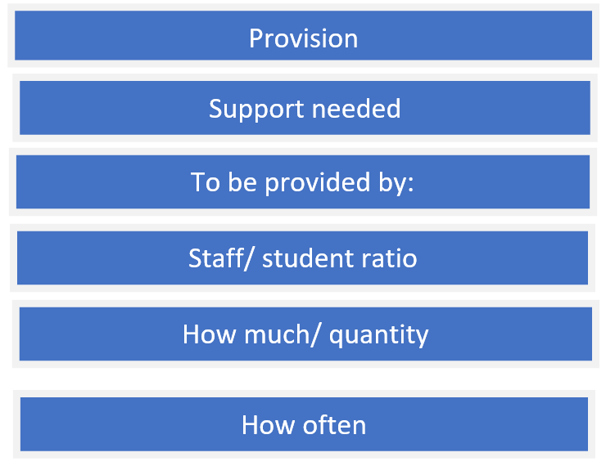 | - Provision must be detailed and specific and should normally be quantified; for example, in terms of the type of support and who will provide it.  - It should be clear how the provision will support achievement of the outcomes, including the health needs to be met and the outcomes to be achieved through provision secured through a personal (health) budget.  - Health care provision reasonably required may include specialist support and therapies, such as medical treatments and delivery of medications, occupational therapy and physiotherapy, a range of nursing support, specialist equipment, wheelchairs and continence supplies etc.  - Occupational therapy and physiotherapy or other therapies will be listed as educational provision when they educate or train a child or young person. It may be possible for therapy to appear under both health and educational provision if some provision relates to educational needs and some provision is needed for a health need.  - The LA and CCG may also choose to specify other health care provision reasonably required by the child or young person, which is not linked to their learning difficulties or disabilities, but which should sensibly be co-ordinated with other services in the plan.  Tips -  - Case law has established that speech and language therapy is normally always special educational provision (Section F) as communication is so fundamental to learning.  - Once specified in this section, the provision must be secured by the relevant health commissioning body. Only provision “reasonably” required must be included in this section, and health authorities can refuse to have provision included, whether reasonably required or not. This section is therefore open to provision not being included on grounds of cost or convenience, unlike special educational provision in Section F.

In a Rotherham EHC plan sections D, E, H1 and H2 are contained alongside each other to make it easier to identify what the child’s social care need(s) is, what outcome they are to be supported to achieve and the social care provision they will require to help them achieve this.

Section D | 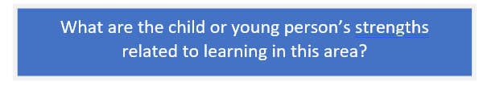  What are the child or young person’s social care needs related to learning in this area? | - The EHC plan must specify any social care needs identified through the EHC needs assessment which relate to the child or young person’s SEN or which require provision for a child or young person under 18 under section 2 of the Chronically Sick and Disabled Persons Act 1970, e.g.  - Struggling within the home to complete normal day-to day activities independently  - Struggling to access the community independently  - The Local Authority may also choose to specify other social care needs which are not linked to the child or young person’s SEN or to a disability. This could include reference to any child in need or child protection plan. Such an approach could help the child and their parents manage the different plans and bring greater co-ordination of services. Inclusion must only be with the consent of the child and their parent.  Tip –  Bear in mind…  - Information about social care needs may come from a range of people, e.g. teachers, Early Help workers or an allocated social worker – if there is any information missing on your child’s social care needs, has this been provided by other professionals in their reports? If so, you can ask for this information to be added to this section of the plan.  - If your child is not known to social care, this does not necessarily mean they have no social care needs.
Section E |  | - There should be a range of outcomes over varying timescales, covering social care.  - There must be a clear distinction between outcomes and provision. The provision should help the child or young person achieve an outcome; it is not an outcome in itself.  Tip –  Bear in mind…  - Outcomes should be specific, measurable, achievable, realistic and time bound.  - Outcomes should follow on from the aspirations identified in Section A.  - Short-term, service level targets should be included as an appendix, not as an outcome.
Section H1 |  | - Section H1 relates only to children and young people under 18 who are receiving social care provision under section 2 of the Chronically Sick and Disabled Persons Act 1970 (CSDPA).  - Provision should be detailed and specific and should normally be quantified, for example, in terms of the type of support and who will provide it (including where this is to be secured through a social care direct payment).  - It should be clear how the provision will support achievement of the outcomes.  - Section H1 of the EHC plan must specify all services assessed as being needed for a disabled child or young person under 18, under section 2 of the CSDPA. These services may include:  - practical assistance in the home  - provision or assistance in obtaining recreational and educational facilities at home and outside the home  - assistance in travelling to facilities  - adaptations to the home  - facilitating the taking of holidays  - non-residential short breaks (included in Section H1 on the basis that the child as well as his or her parent will benefit from the short break)  - This may include services to be provided for parent carers of disabled children, including following an assessment of their needs under sections 17ZD-17ZF of the Children Act 1989  Tip - If your child receives a package of social care support and this is not detailed in the EHC plan, ask for it to be included in H1/H2, depending on the type of support it is.
Section H2 |  | - Social care provision reasonably required may include provision identified through Early Help and children in need assessments and safeguarding assessments for children.  - Section H2 must only include services which are not provided under Section 2 of the CSDPA. For children and young people under 18 this includes residential short breaks and services provided to children, arising from their SEN but unrelated to a disability. This should include any provision secured through a social care direct payment [See chapter 10 of the SEND Code of Practice 0-25 for more information on children’s social care assessments].  Tip - Please bear in mind that this is only provision “reasonably” required, so LAs can take into account cost and convenience, unlike the provision in Section F.

Section I | Placement | - The details of placement are only included in the final plan so that the LA does not pre-empt consideration of any preference for an institution which the parents or young person may state, or any representation the parents or young person may make in favour of an independent school or institution.  Tip - you may find it useful to familiarise yourself with the information on ‘Requests for a particular school, college or other institution’ from paragraph 9.78 in the SEND Code of Practice 0-25 and our factsheet on finding a school and applying for a place.
Section J | Budget and Direct Payments | - This section should provide detailed information of any personal budget that will be used to secure provision in the EHC plan.  - It should set out the arrangements in relation to direct payments as required by education, health and social care regulations.  - The special educational needs and outcomes that are to be met by any direct payments must be specified.  Tip – our factsheet on Personal Budgets offers further information on this option.
Section K | Appendices- advice and information gathered during the process | - The advice and information gathered during the EHC needs assessment must be set out in appendices to the EHC plan. There should be a list of this advice and information.  Tip – you should be provided with a copy of this these reports alongside the draft EHC plan.
More information on EHC plans can be found in the SEND Code of Practice 0-25, Chapter 9.

Once you share your views on the contents of the EHC plan with the allocated EHC co-ordinator, you should hear back from them as soon as practicable. Remember to save a copy of any letter/email you send. If you don’t have a reply within two weeks try following this up via phone. The EHC team can be reached on 01709 822660 or via email at ASSENT@rotherham.gov.uk.
Rotherham SEND Information, Advice and Support Service  Riverside House, Main Street  Rotherham, S60 1AE  Tel: 01709 823627  www.rotherhamsendiass.org.uk  E-Mail: parent.partnership@rotherham.gov.uk | 

